1. To Create Main Loop
Display Prompt
Read User Input
Handle Exit Conditions
Design Control Flow Diagram
Test Interactive Loop
2. To Capture Keyboard Input
Handle Backspace
Process Enter Key
Manage Input Buffer
Support Multi-Character Commands
Test User Interaction
Code:

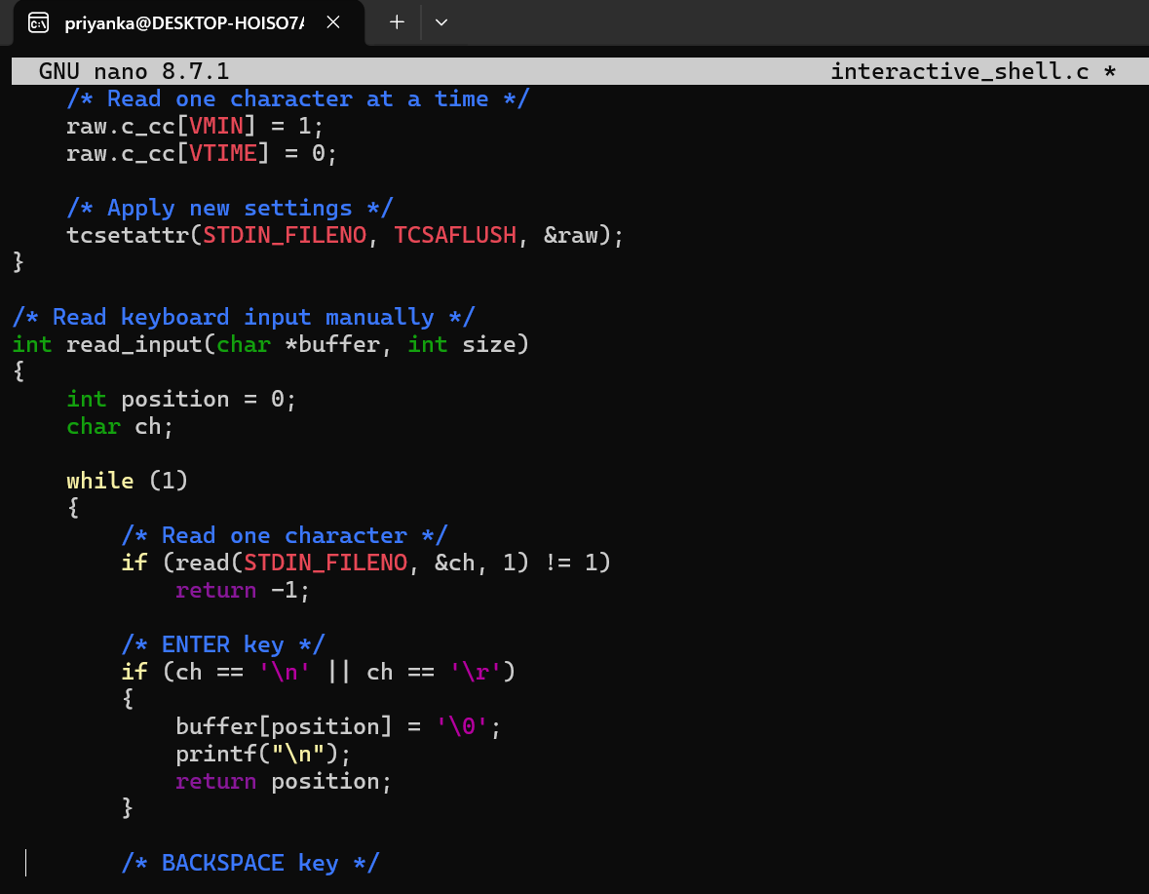
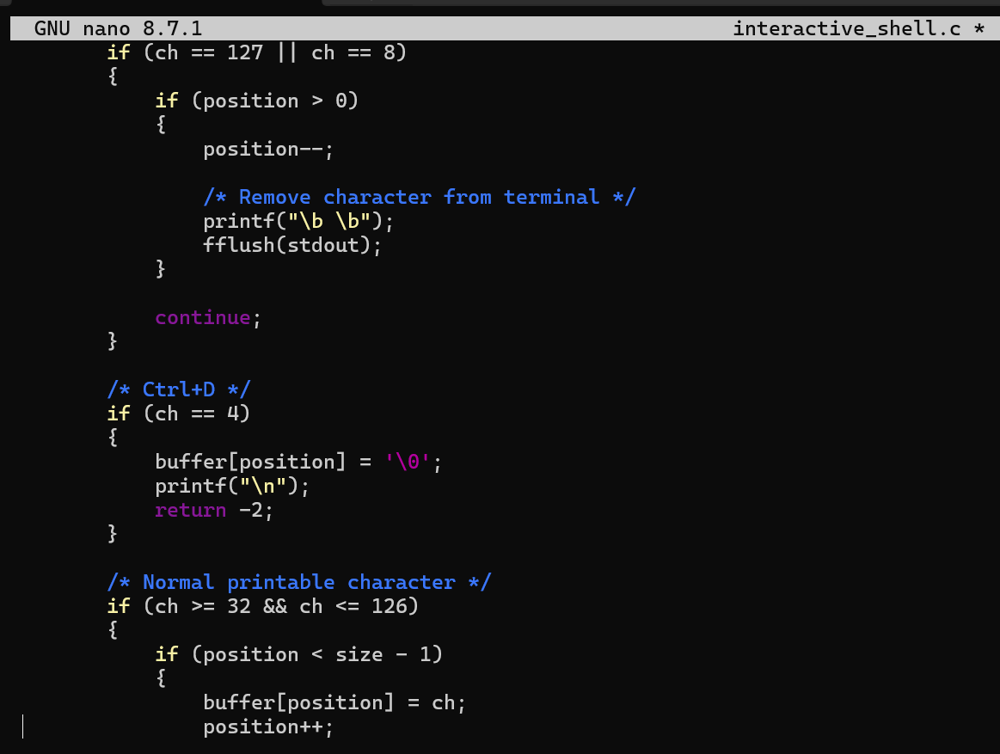
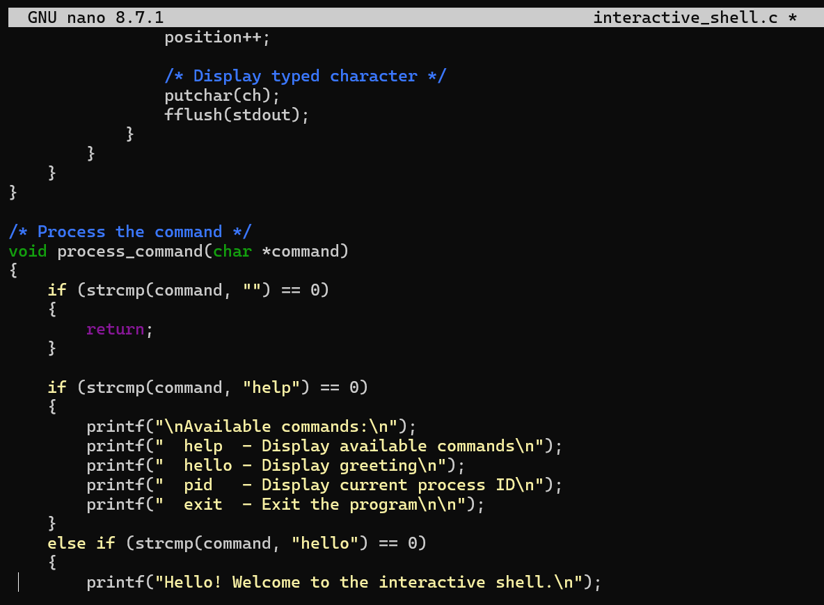
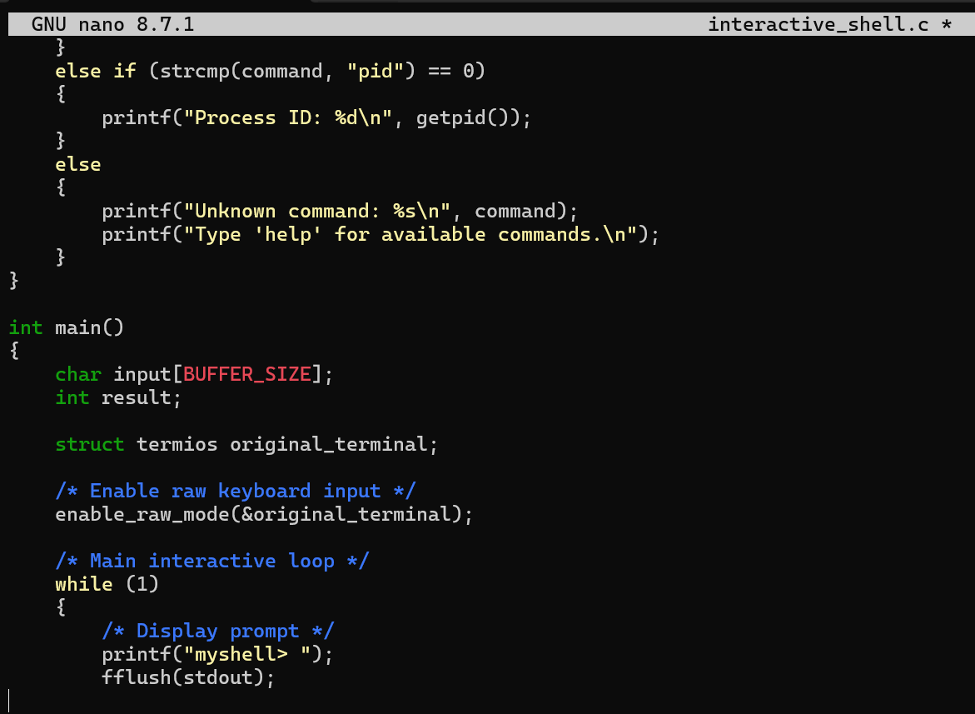
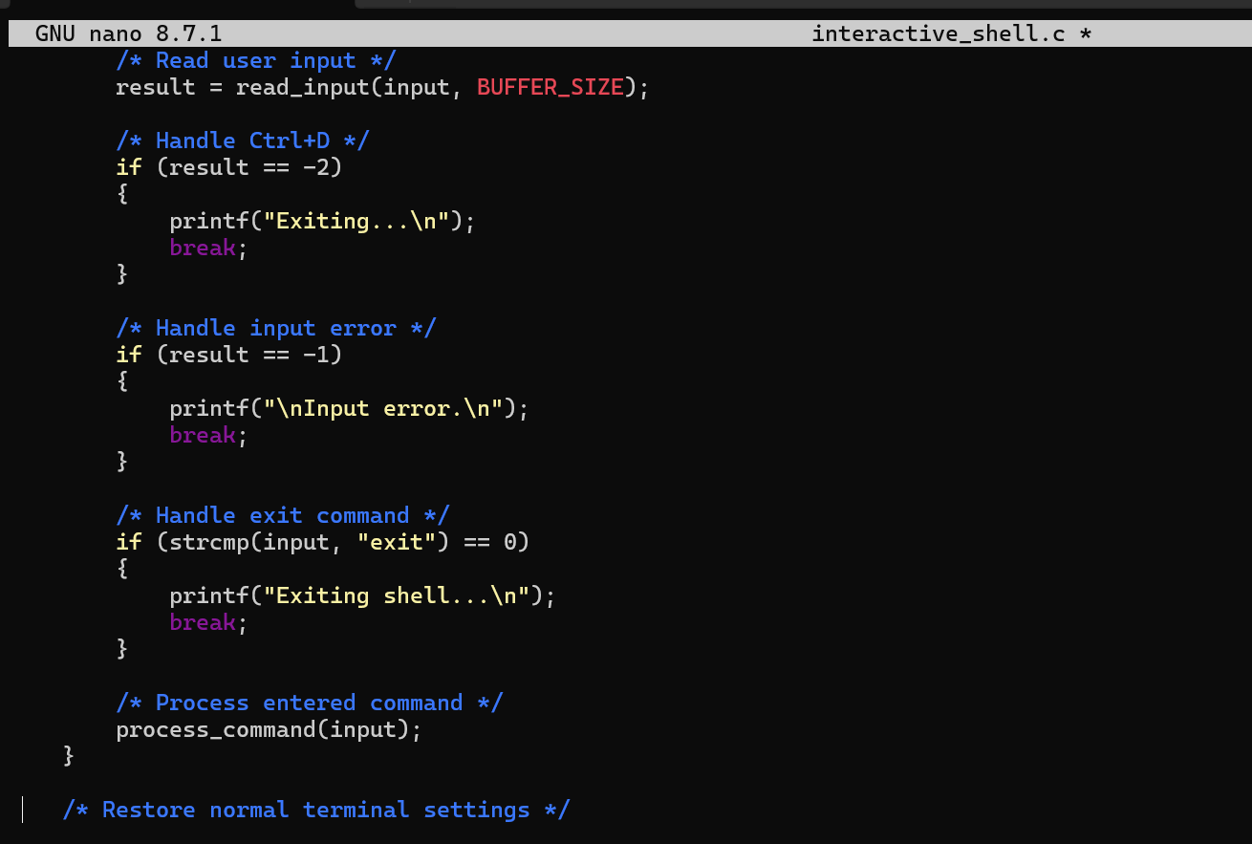

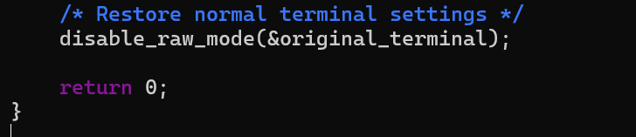
Output:
